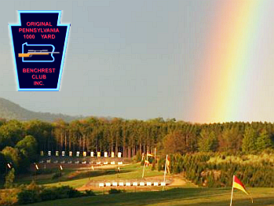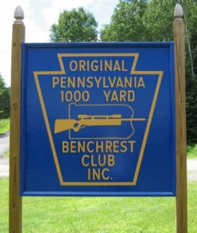
Greetings;

Thank you for your interest in our benchrest school. Class will start Saturday June 6th, 2020 and conclude Sunday June 7th, 2020. There will be a meet and greet on Friday night (June 5th) but it’s not mandatory to be here Friday. Class will start at 9:00 am sharp on Saturday so please try and be a little early.

We provide you with all the equipment needed for the weekend but if you have a rifle and would like to bring it that’s fine. I can’t promise everyone will be able to use their own equipment, but we will cover that on a case by case basis.

Seats are limited. To reserve a seat payment must be made in full prior to May 22, 2020. No seats will be reserved without payment.

Attached you’ll find the application. Please fill it out and send it back along with your payment of $475.00 per person to the address below. Seats are reserved on first come first served basis so get your application in early.

If you have any questions, feel free to email: Andy Murtagh, Joe Saltalamachia or Eric Wolfgang. Email addresses are listed under the ‘CONTACT US’ tab on www.pa1000yard.com

Please mail applications to:

Original PA 1000 Yard Benchrest Club, Inc.
P.O. Box 218
Allenwood, PA 17810

**Note** We are continuing to offer a ‘FREE’ 1-year membership to our club included with your entry fee. Lunches are provided on Saturday and Sunday as well as dinner on Saturday evening by our club.

Lodging is at the expense of the student. Camping is available on site, with electrical hook-up for $15 per day. Camping is free if no electricity is required. Our clubhouse is equipped with shower facilities for men and women.
There are several fine hotels in the nearby greater Williamsport Area. Williamsport is approximately 20 miles south of the range.

Original Pennsylvania 1000 Yard Benchrest Club
2020 Benchrest School Application

Name________________________________________________
Address_____________________________________________
City, State, Zip______________________________________
Email_______________________________________________
Cell Phone (_____)______-___________________

T-Shirt Size:
SM___MED____LG___XL_____2XL_____3XL____ Other____

Experience in Benchrest and reloading (none is fine)
___________________________________________________________________
______________________________________________________________________________________________________________________________________
Competitive Benchrest experience
______________________________________________________________________________________________________________________________________
What distance? _____________________________________
Do you own a benchrest rifle? _______
Are you planning on bringing it to the school? ________

Why do you want to attend the school?
Expectations?___________________________________________________________________________________________________________________________________________________________________________________________

Mail completed application along with fee ($475.00) nonrefundable to:

Original Pa.1000 Yard Benchrest Club,
PO Box 218,
Allenwood, PA 17810

Other information contact Andy Murtagh, Joe Saltalamachia or Eric Wolfgang via www.pa1000yard.com (under the CONTACT US tab)

